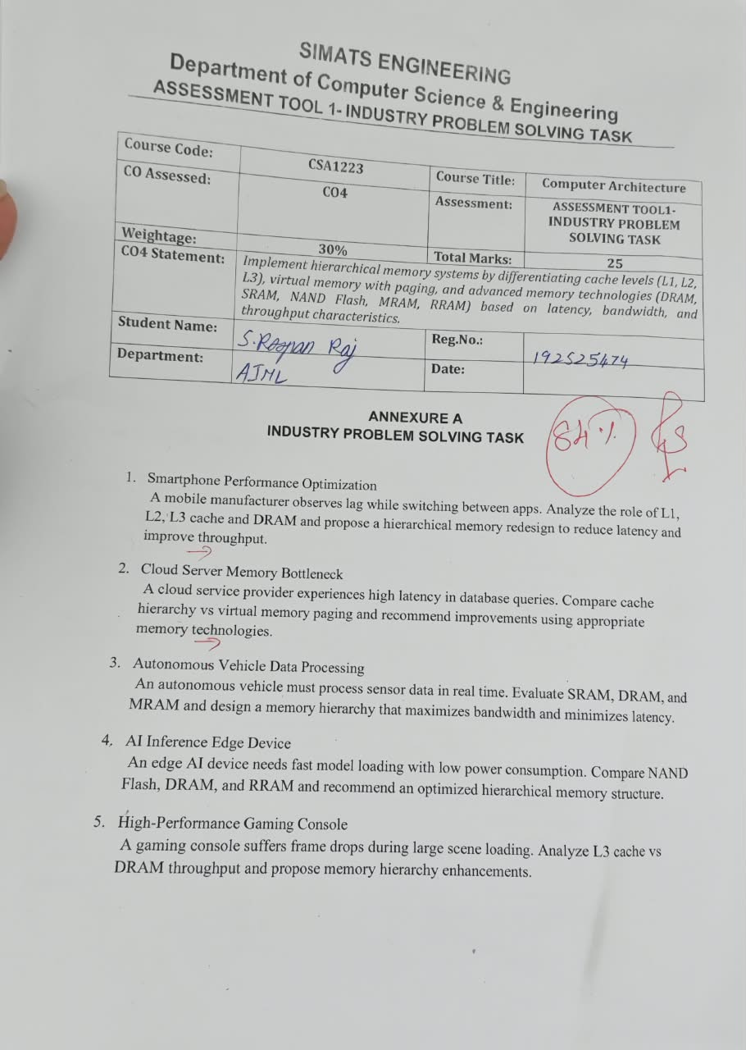

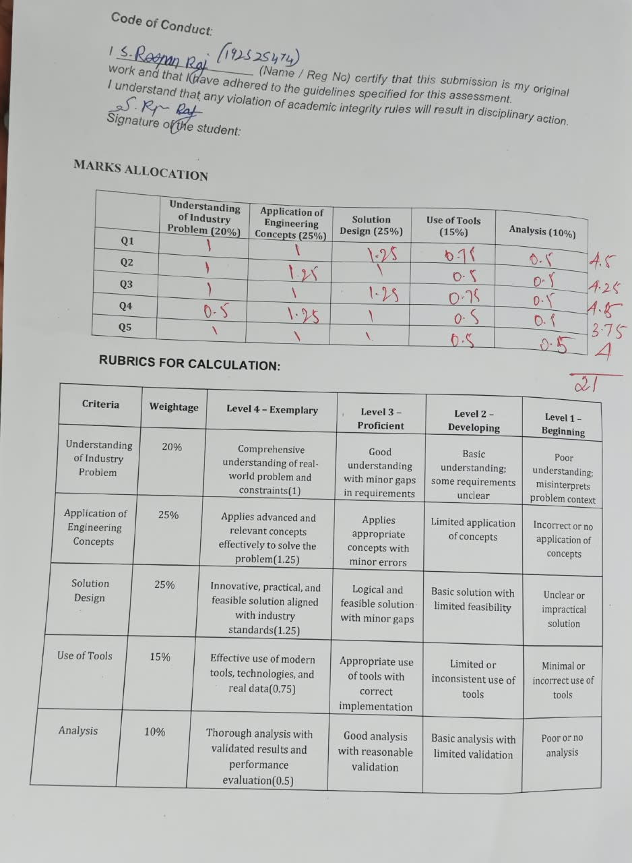

SIMATS ENGINEERING
Department of Computer Science & Engineering
ASSESSMENT TOOL 1- INDUSTRY PROBLEM SOLVING TASK

Course Code: | CSA1223 | Course Title: | Computer Architecture
CO Assessed: | CO4 | Assessment: | ASSESSMENT TOOL1- INDUSTRY PROBLEM SOLVING TASK
Weightage: | 30% | Total Marks: | 25
CO4 Statement: | Implement hierarchical memory systems by differentiating cache levels (L1, L2, L3), virtual memory with paging, and advanced memory technologies (DRAM, SRAM, NAND Flash, MRAM, RRAM) based on latency, bandwidth, and throughput characteristics.
Student Name: |  | Reg.No.:
Department: |  | Date:

ANNEXURE A
INDUSTRY PROBLEM SOLVING TASK

- Smartphone Performance Optimization
A mobile manufacturer observes lag while switching between apps. Analyze the role of L1, L2, L3 cache and DRAM and propose a hierarchical memory redesign to reduce latency and improve throughput.
Answer:
Cache & Memory Analysis:
• L1 cache: per-core, ~1-2 cycle latency, holds instructions/data of the currently active app; too small to retain context of multiple apps.
• L2 cache: shared within a core cluster, ~10 cycle latency; absorbs L1 misses but still limited in capacity for multitasking.
• L3 cache: shared across all cores, ~30-40 cycle latency, larger capacity; acts as the last buffer before DRAM.
• DRAM: ~100+ cycle latency, holds the full working set of every open app; app switching forces cache flushes and DRAM re-fetches, which is the main source of lag.
Proposed Hierarchical Memory Redesign:
• Enlarge L2 per-cluster cache so recently used app context survives short switches without falling back to DRAM.
• Use an exclusive/victim-cache policy between L2 and L3 so data evicted from L2 is retained in L3 instead of being discarded.
• Adopt LPDDR5X DRAM for higher bandwidth and lower access latency during context reload.
• Add an ML-based prefetcher that predicts the next likely app and preloads its data into L2/L3 ahead of the switch.
• Use memory compression (zRAM-style) so more background app states stay in fast RAM instead of being swapped to flash storage.
Expected Outcome:
• Lower cache-miss penalty during app switching, reduced perceptible lag, higher throughput, with minimal extra power draw - important for battery life.
Comparative Analysis:
Memory Level | Typical Latency | Typical Capacity | Bandwidth | Volatility | Role in Redesign
L1 Cache | 1-2 cycles | 32-64 KB/core | Very High | Volatile | Active-app hot data
L2 Cache | ~10 cycles | 256KB-1MB | High | Volatile | Enlarged for context retention
L3 Cache | 30-40 cycles | 2-8 MB | Medium-High | Volatile | Victim cache for evicted L2 data
DRAM (LPDDR5X) | 100+ cycles | 6-16 GB | High (~40+ GB/s) | Volatile | Full app working set, faster reload

Tools & Technologies Used for Analysis:
• CACTI - to model and estimate cache access latency, area, and power for different L1/L2/L3 sizing options.
• gem5 simulator - to simulate the mobile SoC memory hierarchy and measure hit/miss rates during app-switch workloads.
• Android Profiler / Perfetto - to trace real app-switch events and identify cache-miss/latency hotspots on-device.
• MATLAB / Excel-based latency-bandwidth modeling - to compare the proposed hierarchy's performance against the baseline analytically.
- Cloud Server Memory Bottleneck
A cloud service provider experiences high latency in database queries. Compare cache hierarchy vs virtual memory paging and recommend improvements using appropriate memory technologies.
Answer:
Cache Hierarchy vs Virtual Memory Paging:
• Cache (L1-L3): nanosecond latency but only megabytes in size; effective only for hot/frequently reused query data, fully hardware-managed.
• Virtual memory with paging: gigabytes-terabytes of addressable space, OS-managed; a page fault or TLB miss can cost microseconds to milliseconds, causing the latency spikes seen in large database workloads.

Recommendations using appropriate Memory Technologies:
• Introduce a tiered memory architecture: DRAM as the primary tier backed by non-volatile memory (NVDIMM / MRAM or RRAM-based) as a next tier to absorb page faults faster than disk.
• Enable huge pages (2MB/1GB) to cut down page-table walk overhead and TLB misses for large index/table scans.
• Deploy an in-memory caching layer (e.g., Redis-style DRAM cache) in front of the database to directly serve hot queries and bypass page faults.
• For cold/archival data, use NAND-flash based SSDs as the paging/swap device instead of HDDs to reduce fault-service time.
• Tune OS read-ahead and hardware prefetchers to match the database's access pattern (sequential vs random).
Expected Outcome:
• Query latency drops and throughput rises because hot data stays in cache/DRAM while cold data is served from a fast NVM/SSD tier instead of causing expensive page faults.
Comparative Analysis:
Approach | Typical Latency | Managed By | Capacity | Cost/GB | Best Fit
L1-L3 Cache | 1-40 cycles | Hardware | KB-MB | Very High | Hot query data reuse
DRAM (main memory) | ~100 cycles | OS/Hardware | GB | High | Active working set
Paging to NVM/SSD | us range | OS (virtual memory) | GB-TB | Medium | Warm data, page-fault absorb
Paging to HDD | ms range | OS (virtual memory) | TB+ | Low | Cold/archival data only

Tools & Technologies Used for Analysis:
• perf / Linux vmstat - to profile page-fault rate, TLB misses, and cache-miss statistics on the database server.
• pgbench / sysbench - to benchmark database query throughput and latency before and after the proposed changes.
• DRAMSim3 - to simulate DRAM-tier behavior and estimate the benefit of huge pages and tiered NVM.
• Redis / Memcached (as reference in-memory caching tools) - to model the impact of adding a DRAM caching layer.
- Autonomous Vehicle Data Processing
An autonomous vehicle must process sensor data in real time. Evaluate SRAM, DRAM, and MRAM and design a memory hierarchy that maximizes bandwidth and minimizes latency.

Answer:
Evaluation of SRAM, DRAM, MRAM:
• SRAM: fastest, lowest latency, low density and higher cost/area - best for tightly-coupled real-time control-loop data.
• DRAM: higher density and capacity at moderate latency - suited to buffering large streaming sensor data (camera/LiDAR/radar frames).
• MRAM: non-volatile, near-SRAM speed with very high write endurance - ideal for retaining critical safety state so it survives sudden power loss.
Proposed Memory Hierarchy Design:
• L1: SRAM tightly coupled to the processing cores running perception/sensor-fusion algorithms for minimum latency.
• L2/L3: larger embedded SRAM/DRAM cache with a high-bandwidth interconnect to buffer multi-sensor streaming data.
• Main memory: high-bandwidth DRAM (LPDDR5/GDDR6-class) for neural-network inference buffers and large working sets.
• Persistent safety layer: MRAM to store last-known-good vehicle state (position, safety flags) for instant, lossless recovery after a power glitch.
• Connect all tiers through a QoS-aware network-on-chip that prioritizes safety-critical data paths.
Expected Outcome:
• Maximized bandwidth for continuous sensor throughput, minimized latency for real-time safety decisions, and resilience against power interruptions.
Comparative Analysis:
Technology | Latency | Bandwidth | Volatility | Endurance | Best Use in Design
SRAM | Sub-ns | Very High | Volatile | Very High | Real-time control loop, L1 cache
DRAM (LPDDR5/GDDR6) | ~10-15 ns | Very High (100+ GB/s) | Volatile | High | Sensor stream buffers, NN inference
MRAM | ~10-20 ns | Medium-High | Non-volatile | Very High (10^15 cycles) | Safety-critical state retention

Tools & Technologies Used for Analysis:
• ROS (Robot Operating System) profiling tools / rqt - to trace sensor-data pipeline timing and identify bandwidth bottlenecks.
• gem5 / DRAMSim3 - to simulate the SRAM-DRAM-MRAM hierarchy under real sensor-fusion workload traces.
• CACTI - to estimate latency, energy, and area trade-offs across SRAM/DRAM/MRAM configurations.
• MATLAB/Simulink - to model real-time control-loop timing constraints against the proposed memory hierarchy.
- AI Inference Edge Device
An edge AI device needs fast model loading with low power consumption. Compare NAND Flash, DRAM, and RRAM and recommend an optimized hierarchical memory structure.
Answer:
Comparison of NAND Flash, DRAM, RRAM:
• NAND Flash: non-volatile, high density, low cost per GB, but slow read/write - suited for bulk, persistent model storage.
• DRAM: fast, volatile, higher power draw - typically used for active weights/activations during inference.
• RRAM: non-volatile, near-DRAM read speed, low power, supports in-memory compute - well suited for fast model loading with low energy cost.
Recommended Optimized Hierarchical Memory Structure:
• NAND Flash as cold storage for the full library of trained models/datasets not currently in use (cost-effective, large capacity).
• RRAM as a fast, non-volatile model-cache layer that loads weights almost instantly at power-up, avoiding a slow NAND read.
• A small DRAM tier limited to runtime activation buffers only, since DRAM is the most power-hungry tier.
• On-chip SRAM cache for the final compute stage to keep the most active weights closest to the processing element.
• Where feasible, use RRAM-based compute-in-memory to perform matrix multiplications directly in the memory array, cutting data-movement energy.
Expected Outcome:
• Near-instant model loading, significantly lower power consumption suited to battery-powered edge devices, while still retaining large-capacity storage via NAND Flash.
Comparative Analysis:
Technology | Read Latency | Write Latency | Volatility | Power | Best Use
NAND Flash | ~25-50 us | ~200-500 us | Non-volatile | Low (idle) | Bulk model/dataset storage
DRAM | ~10-15 ns | ~10-15 ns | Volatile | High (refresh) | Runtime activation buffers
RRAM | ~10-50 ns | ~10-50 ns | Non-volatile | Very Low | Fast model cache, in-memory compute

Tools & Technologies Used for Analysis:
• NVSim - to model RRAM/NAND access latency, energy, and area for the memory-technology comparison.
• TensorFlow Lite / ONNX Runtime benchmarking tools - to measure model-loading time and inference latency on the edge device.
• Intel VTune / perf - to profile power and memory-access hotspots during model load and inference.
• MATLAB/Excel power-modeling sheet - to estimate energy savings of the RRAM-based cache versus a DRAM-only baseline.
- High-Performance Gaming Console
A gaming console suffers frame drops during large scene loading. Analyze L3 cache vs DRAM throughput and propose memory hierarchy enhancements.
Answer:
L3 Cache vs DRAM Throughput Analysis:
• L3 cache: shared, moderate latency, but only a few MB in size - great for reused shader/texture data, insufficient for entire large scenes, so big loads cause frequent misses.
• DRAM (GDDR6/GDDR6X): very high bandwidth (hundreds of GB/s) and large capacity, but higher latency than cache; the console stalls while textures/geometry are streamed from storage into DRAM/cache during a big scene load, producing frame drops.
Proposed Memory Hierarchy Enhancements:
• Increase effective L3 (or add an eDRAM victim cache) to retain frequently reused shader/texture data across frames and cut DRAM traffic during steady gameplay.
• Use high-bandwidth GDDR6X/HBM-class DRAM to raise sustained throughput for large asset streaming.
• Implement asynchronous, predictive asset streaming from an NVMe SSD with dedicated hardware decompression, so data is prefetched into DRAM/cache before it's needed on screen.
• Apply texture compression and level-of-detail (LOD) streaming to shrink the data volume moved during scene transitions.
• Partition cache/QoS so background asset streaming cannot evict the cache lines needed by the actively rendering frame.
Expected Outcome:
• Fewer stalls and frame drops during large scene loads, higher sustained throughput, and smoother, more consistent frame pacing.
Comparative Analysis:
Memory Tier | Latency | Bandwidth | Capacity | Volatility | Role
L3 Cache (+eDRAM) | ~30-40 cycles | Very High | 8-32 MB | Volatile | Reused shader/texture cache
GDDR6X DRAM | Higher than cache | ~500-900 GB/s | 10-16 GB | Volatile | Active scene assets, framebuffer
NVMe SSD | us range | 5-7 GB/s | 500GB-2TB | Non-volatile | Predictive asset streaming source

Tools & Technologies Used for Analysis:
• GPU profilers (e.g., RenderDoc / PIX) - to trace frame timing and identify memory-stall points during scene loads.
• gem5 / DRAMSim3 - to simulate the L3-DRAM-SSD hierarchy under a game asset-streaming workload trace.
• CACTI - to model cache/eDRAM latency-area-power trade-offs for the enlarged L3 tier.
• fio / CrystalDiskMark-style benchmarks - to measure NVMe SSD sequential/random throughput for predictive streaming design.

Code of Conduct:

I ____________________ (Name / Reg No) certify that this submission is my original work and that I have adhered to the guidelines specified for this assessment.
I understand that any violation of academic integrity rules will result in disciplinary action.

Signature of the student:

MARKS ALLOCATION
 | Understanding of Industry Problem (20%) | Application of Engineering Concepts (25%) | Solution Design (25%) | Use of Tools (15%) | Analysis (10%)
Q1
Q2
Q3
Q4
Q5

RUBRICS FOR CALCULATION:

Criteria | Weightage | Level 4 – Exemplary | Level 3 – Proficient | Level 2 – Developing | Level 1 – Beginning
Understanding of Industry Problem | 20% | Comprehensive understanding of real-world problem and constraints(1) | Good understanding with minor gaps in requirements | Basic understanding; some requirements unclear | Poor understanding; misinterprets problem context
Application of Engineering Concepts | 25% | Applies advanced and relevant concepts effectively to solve the problem(1.25) | Applies appropriate concepts with minor errors | Limited application of concepts | Incorrect or no application of concepts
Solution Design | 25% | Innovative, practical, and feasible solution aligned with industry standards(1.25) | Logical and feasible solution with minor gaps | Basic solution with limited feasibility | Unclear or impractical solution
Use of Tools | 15% | Effective use of modern tools, technologies, and real data(0.75) | Appropriate use of tools with correct implementation | Limited or inconsistent use of tools | Minimal or incorrect use of tools
Analysis | 10% | Thorough analysis with validated results and performance evaluation(0.5) | Good analysis with reasonable validation | Basic analysis with limited validation | Poor or no analysis

